Food Access
Impact Score
0 20-24 30
Food security is “the condition in which all people, at all times, have physical, social and economic access to sufficient, safe and nutritious food that meets their dietary needs and food preferences for an active and healthy life.”
Source: International Food Policy Research Institute
Health Impacts  Increased risk of:  - Overweight and obesity  - Cancer  - Diabetes  - Cardiovascular Diseases  - Malnutrition  Source: WHO | Comparison  Food Insecurity, Marion Co. vs. other locations, 2016  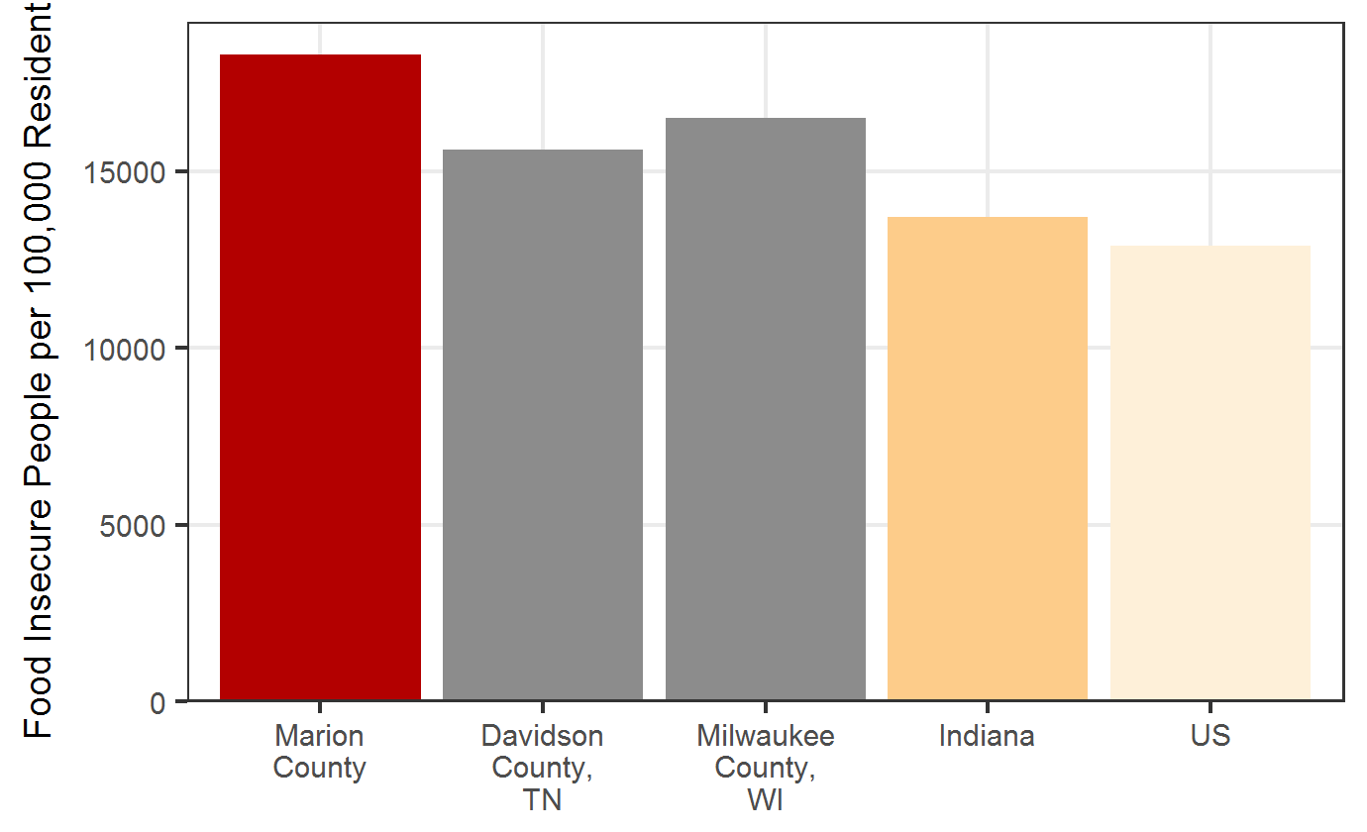  Source: Feeding America

Treatment
- Establish community gardens
- Organize local farmers markets
- Improve local transportation
- Change zoning codes
- Offer incentives to attract retailers with healthier food options to food desert areas
Source: Centers for Disease Control and Prevention

Trend
Marion Co. SNAP Households, 2012-2016
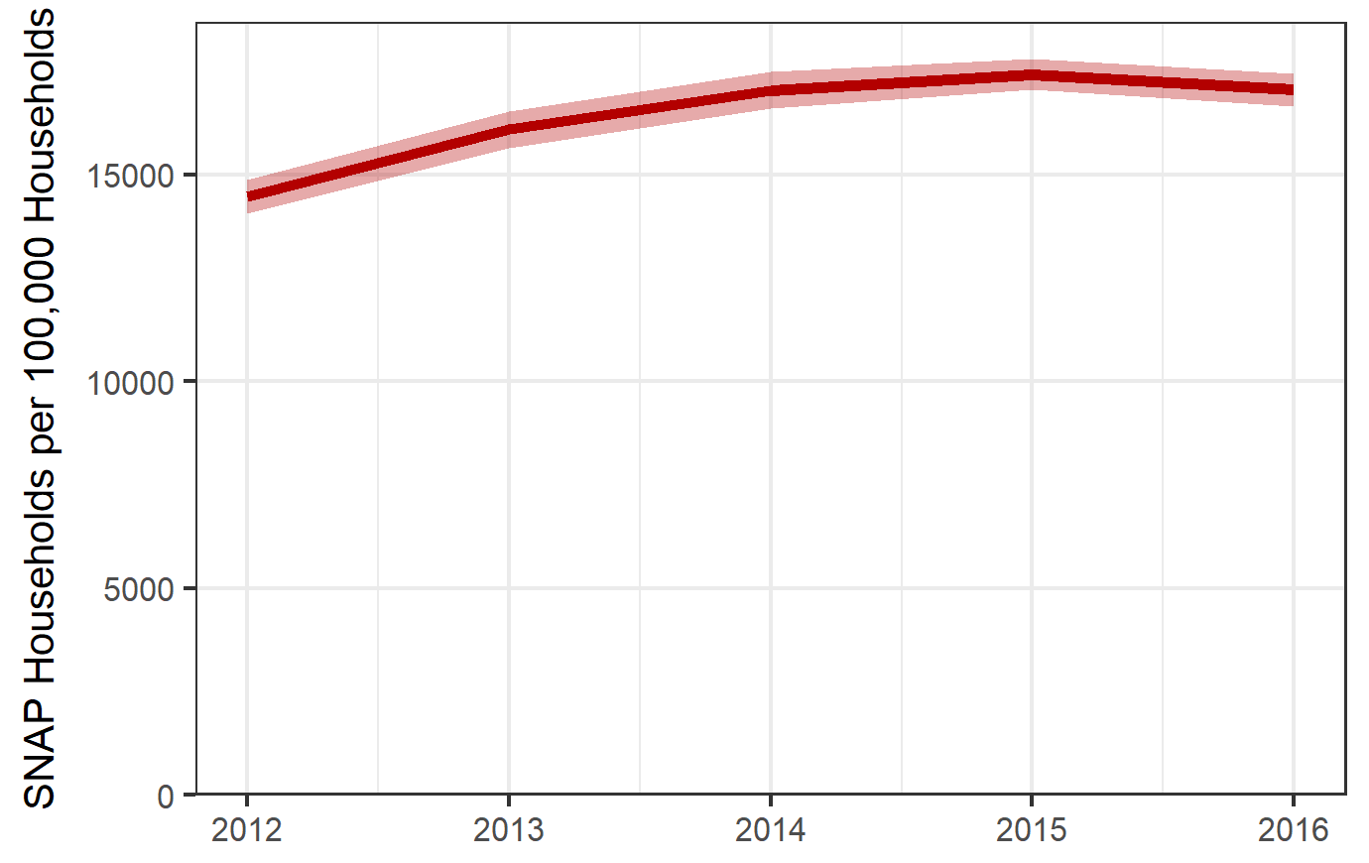
Source: ACS 5 Year Summaries

DR3792

Risk Factors
- Low-income households
- Households with children
- Single-parent households
- Households headed by Black, non-Hispanics or Hispanics (as compared to White, non-Hispanics)
- Adults with a mental health disability
Source: United State Department of Agriculture

Equity
Food Deserts, Marion Co.
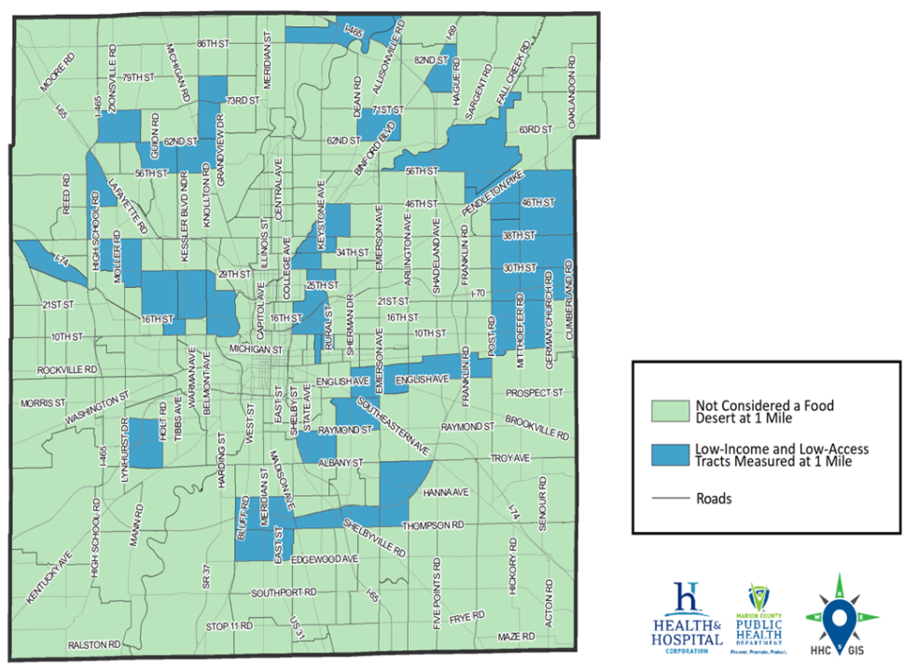
Source: Epidemiology Department, DR3512
About 21% of Marion County residents live in a food desert. A food desert is a low-income census tract in which at least 500 people or at least 33% of the population living more than 1 mile from the nearest supermarket, supercenter, or large grocery store.

